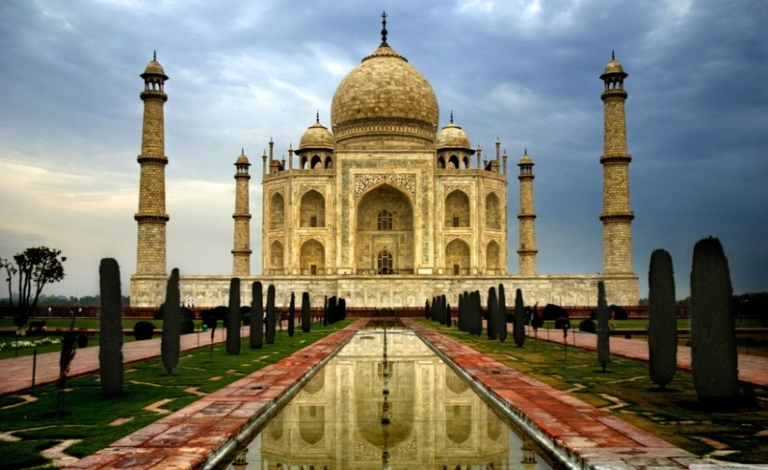
Trip Duration 10 days

The Experience
A fascinating healing yoga journey through the birthplace of yoga and meditation….India. Experience its diverse architecture, culture and most importantly the people.
Located along the south western coast of India, Kerala is a tropical bliss with an idyllic coastline and lush tropical hills. Rightly dubbed “God’s Own Country” Kerala boasts a rich flora and fauna, spice plantations, a harmonious mixture of communities, hill stations, serene backwaters, beaches and more. Kerala has been included in the top 50 destinations for a once in a lifetime visit by National Geographic Channel. Ayurveda treatments, yoga and meditation, fishing with local fishermen are some popular activities at Kerala.

Trip highlights
- UNESCO’s Heritage Site visit
- Taj Mahal by Sunrise
- Ashram visits
- Yoga Sessions in Haridwar and Agra
- Meditation session at Sadhak Grama Ashram
- Aarti ceremony in Rishikesh
- yoga sessions on the Holy Ganges
- yoga sessions at the beach
- Enchanting Backwaters cruise
- Malabar Coast beach front stay

TOUR ITINERARY

Day 01 Delhi Arrival

Arrive at Delhi airport, meet and assistance by our office representative, followed by a transfer to your Hotel and check-in on arrival for your dinner and overnight stay. (Half-board)

Day 02 Delhi – Agra ( 204 km / 4 hrs)

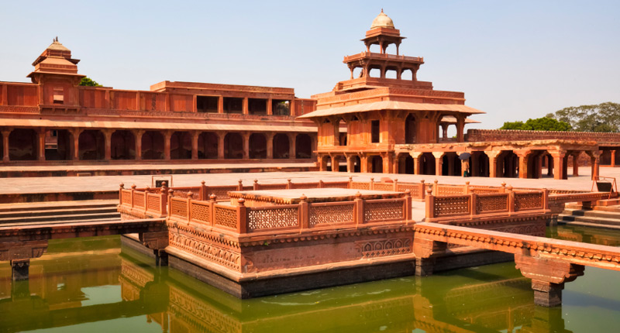
After breakfast at the Hotel, you will proceed for sightseeing tour. This splendid city has been under human inhabitation since 6th century B.C. and has also been state capital of several empires during ancient and medieval times. You will be taken to visit the famous Qutub Minar, which was declared to be a heritage site by UNESCO and was constructed by a Turkish king, Qutub-ud-din Aibak, in the year 1192. Follow your heritage journey and drive to Agra, on arrival check-in at your hotel. This city is situated on banks of river Yamuna and is also popularly called Akbarabad which was at its peak in the Mughal era. Take a visit to Agra Fort. This fort is famous for its architectural style from the reign of Mughals in about 16th century A.D and also encompasses numerous mythological fortresses and palaces such as Khas Mahal, Jahangir Palace, etc.
Tonight enjoy a special Welcome Dinner at “Pinch of Spices”. Overnight stay at the hotel. (Half-board)

Day 03 Agra – Delhi ( 204 km / 4hrs) – Haridwar (by train : 4hrs)
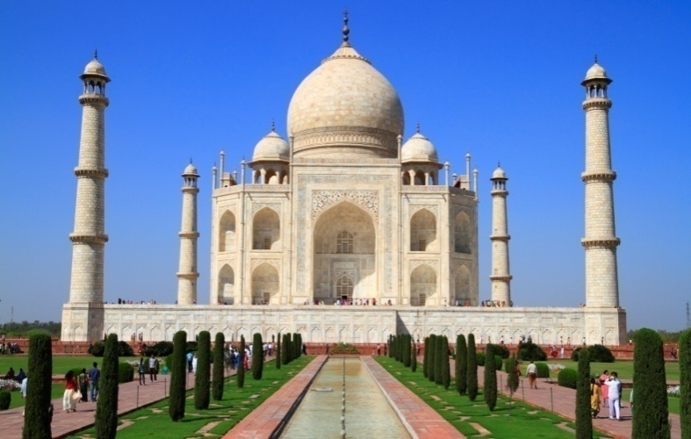
Next morning, you will visit the mesmerizing Taj Mahal at sunrise, when the first rays of sun is reflecting off the glistening white marble of the monument. This breathtaking historical monument is described as the most extravagant monuments ever built for love. It is one of finest examples of Mughal architectural style with some elements of Islamic, Ottoman, Turkish and Persian style of architecture. Back at the Hotel, Enjoy a Yoga Session followed by breakfast. Check-out and drive to Delhi Railway Station to catch the train to Haridwar (Depart 15.20 / Arrival 19.30). On arrival transfer to your hotel for your check-in. Dinner and overnight stay.
(Half-board)

Day 04 Haridwar - Rishikesh – Haridwar (20 km / 1 hr)

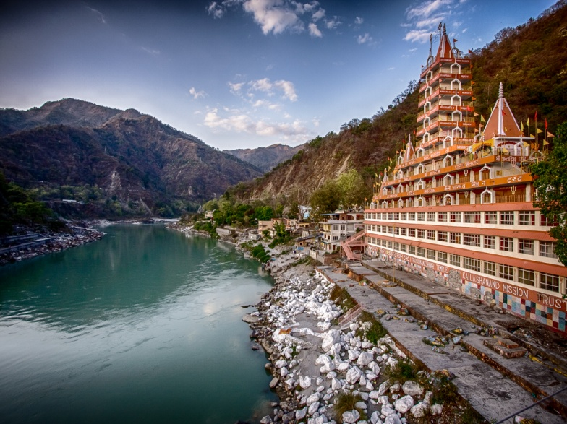
Today after your breakfast and morning yoga session (at the hotel), drive to Rishikesh... This small station is surrounded by forested hills and conducive to yoga and meditation. Ever since the Beatles enrolled at the ashram of the Maharishi Mahesh Yogi in the late ‘60s, Rishikesh has been a magnet for spiritual seekers. Experience a special meditation session at Sadhak Grama Ashram followed by another Yoga session on a ghat (river bank) after a visit to the Aarti ceremony. In the evening, a misty breeze blows down the valley, temple bells ringing as sadhus (spiritual men) and pilgrims prepare for the nightly Ganga Aarti (a fire offering or ritual performed on the Ganges). Return to your hotel in Haridwar for your dinner and overnight stay. (Half-board)

Day 05 Haridwar – Delhi (by train : 4hrs)

Today after your morning yoga session (at the hotel) and breakfast, check-out and drive to Hardiwar train station on time to connect your train back to Delhi (Depart : 18.15 / Arrival Delhi 22.30). On arrival assistance and transfer to your hotel close to Delhi airport. Dinner and overnight stay at the hotel. (Half-board)

Day 06 Delhi – Cochin (by Flight: 4hrs) – Marari ( 90 km /2.5 hrs)

Breakfast at the hotel. Transfer to Delhi Airport on time to connect your flight to Cochin in Kerala. On arrival meet and assistance at the airport, then transfer to your yoga retreat Marari Villas in Marari beach. (The Marari Villas were published as one of the “Top 6 beach retreats in Kerala” by The Independent in 2013 and have been the Number 1 ‘Speciality Lodging’ choice in Marari,for the past 5 years, according to Tripadvisor.) Enjoy a yoga session in the afternoon; followed by dinner and overnight stay at the hotel. (Half-board)

DAY 07 Marari Beach
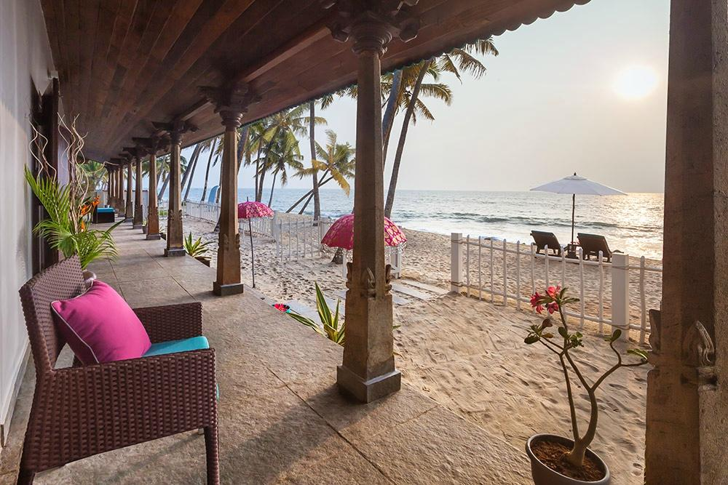
Have a morning yoga session followed by your breakfast. The rest of the day free to relax by the pool of your hotel or to enjoy some Ayurvedic massage and treatments with the local specialists in the Ayurveda in-house rooms at Lotus villa (payable locally). Overnight stay (Half-board).
Day 08 Marari Beach

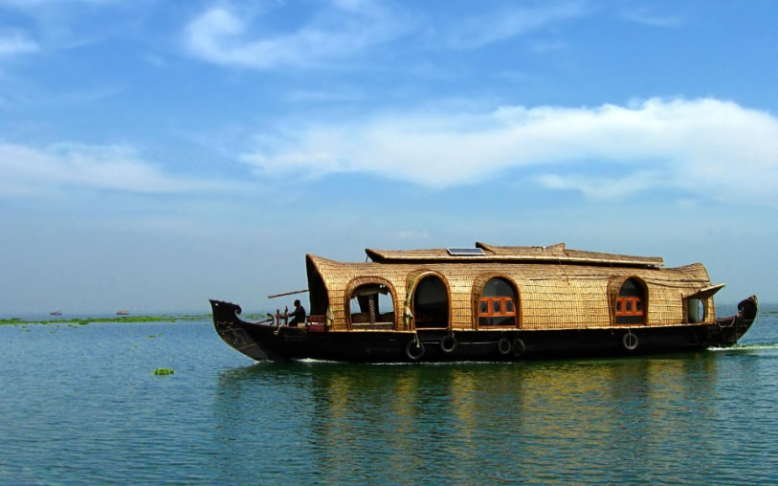
Have a morning yoga session followed by your breakfast. Wait for fishing boats to empty out the day’s catch. Since ages the fishermen go out to the sea in traditional vessels, where no winches, or other modern equipments are used. Every morning after sunrise dozens of boats head for the same spot, called the fish landing. The rest of the day free to relax by the pool of your hotel. Farewell Dinner at the Beach Garden of the hotel. Overnight stay (Half-board).DAY 09 Day 09 Marari - Alleppey Backwaters – Cochin (90 km / 2.5hrs)
Breakfast and morning yoga session (at the hotel).
Check-out and later in the day board your private Houseboat for an enchanting cruise through the Backwaters. These boats are a reworked version of kettuvallams of olden times -once used to carry tons of rice and spices, today are converted into comfortable floating accommodation. Cruise through the palm fringed canals enjoying the beauty of rural village life. A sumptuous Keralan Meal is served on board. The trip continues through a wonderful area of the lush green vegetation of Kerala backwaters. Tea and Local snacks are served before you Disembark and be transferred to your hotel near by the Cochin International Airport for your dinner and overnight stay. (Breakfast, Lunch and Dinner)

Day 10 - Cochin Airport Departure

After your early breakfast, check-out and proceed to Cochin international Airport on time to connect your flight to Delhi for the Air India home bound flight departing at 1315 Hrs.

TOUR ENDS. Namaste!

Tour Cost Per Person:

Validity: October 2017
Tour Cost per Person in Australian Dollars

$ 1960 (Based on 6-8 person travelling)
$ 1925 (Based on 9 - 12 person travelling)

Single supplement : $ 1000 per person

airfares Delhi – Cochin – Delhi approx $125 one way

Hotel Envisaged:

PLACE | NO. OF NIGHTS | SUPERIOR HOTELS
DELHI | 1 | Vivanta by TAJ Dwaraka
AGRA | 1 | Howard Plaza the Fern
HARIDWAR | 2 | Haveli Hari Ganga
DELHI | 1 | Vivanta by TAJ Dwaraka
MARARI | 3 | Marari Villas
COCHIN | 1 | Hotel Casino

TOUR PACKAGE INCLUDES :

- Accommodation on twin sharing basis at all hotels mentioned or similar
- Breakfast and Dinner at all places
- Yoga sessions at the hotels as mentioned in the Itinerary
- Accommodation For the Yoga Teacher in one Single room
- Transportation as per itinerary by chauffeur driven air conditioned vehicle
- Service of local English speaking Guide in Agra, Delhi, Haridwar and Rishikesh
- 1 Yoga class experience in Rishikesh Ghats
- 1 meditation session at Sadhak Grama Ashram
- Train fare for DELHI / HARIDWAR / DELHI in air conditioned Chair car coach
- Backwater Cruise by Private Houseboat with lunch on board
- Entrance charges at the monuments covered in the Itinerary
- Assistance on arrival and departure
- All currently applicable taxes

TOUR PACKAGE DOES NOT INCLUDE:

- Expenses of personal nature such as porterage, laundry, telephones, tipping etc.
- International/Domestic flight charges and Visa/Insurance charges, if any
- Any other items not covered under inclusions

This tour is copyright. Apart from any use permitted under the Copyright Act 1968, no part may be reproduced by any process, nor may any other exclusive right be exercised, without the permission of Soul of Africa Safari Company 2017

Payment and cancellation policies

Payments:
20% - On Confirmation of Tour
50% - 60 Days Prior to Arrival
40% - 30 days Prior to Arrival

Cancellation Policy:
Between 60 - 45 days Prior to Arrival 20% of Total Tour Cost
Between 45 - 30 days Prior to Arrival 25% of Total Tour Cost
Between 30 - 15 days Prior to Arrival 50% of Total Tour Cost
Within 15 days Prior to Arrival 100% of Cancellation Charge

INDIA: How can you possibly prepare yourself for Travel?

To take advantage of your trip, we suggest prepare yourself a little. Here are some travel tips which we hope will be useful, ensuring travel comfort, while travelling in Southern India.
Passport & Visa

In order to enter India you will need:
A signed, valid passport and a tourist visa. Your passport must remain valid for at least 6 months beyond the completion of your trip. It is also imperative that your passport has at least 2 blank visa pages available for entry and exit stamps.
The government of India offers two options for tourist visas. Your entry requirements may vary depending on your nationality. Please consult the nearest diplomatic or consular office of the country or countries you will be visiting.
One option is a multiple entry visa which can be obtained through the traditional application process. This type of visa has a 1 year validity and allows multiple visits and a stay of up to 90 days. You need to apply for a traditional Indian visa if you are exiting and re-entering India during the course of your tour.
The other option is the Electronic Tourist Visa (eTV). This type of visa allows a single entry for a stay of up to 30 days in India. More information regarding the eTV system can be found here https://indianvisaonline.gov.in/visa/tvoa.html. Please read and follow all instructions carefully to avoid any possible complications on arrival in India. Do not apply an eTV any earlier than 34 days and no later than four days before your scheduled date of arrival.

Currency

India's unit of currency is the Indian Rupee.
Exchange currency only at authorized outlets such as exchange kiosks, banks and hotels. Keep receipts of Transactions which may be required when exit the country, and also if you intend to reconvert local currency.
We suggest travelling with some U.S. dollars or Euros, or Sterling Pound to be exchanged for local currency and at least two major credit cards. Hotels and some stores in large cities accept all major credit cards, but in small towns cash may be required. Notify your credit card company of your travel plans prior to your departure to avoid any fraud concerns.
ATM access is available in any cities. Cash is the best (generally, the only) option in street markets.
We do not recommend traveler’s cheques as they are not as widely accepted as in previous years. Lodges outside of major cities do not accept traveler’s cheques.
Health

It is important to familiarize yourself with any potential health issues or concerns related to your destination.
Required Vaccination
A yellow fever vaccination is required to enter India only if you are arriving from or have transited through a yellow fever endemic area in South America or Africa. If vaccination for yellow fever is necessary, you must carry an International Certificate of Vaccination provided by your physician; If you are advised against receiving the vaccination because of your personal medical history, a certificate from your Physician to this effect is required.
Visitors to certain northeastern regions of India (which include Sikkim and Eastern Himalayas) should be aware of higher elevations in these areas. You may experience altitude sickness. Please consult your healthcare provider for suggestions on prevention and treatment.
Climate

India is a huge country and its weather conditions are affected by diverse regions which include mountains, deserts, highlands and coastal plains. In general, India’s climate is warm and tropical although parts of northern and western India can be very cold from December through January.
The months of November to February bring the most pleasant weather throughout the country. Average temperatures in Delhi during this cool season range from daily highs of 60 -80 F to lows between 40 -50 F.
Summer begins in mid-March and lasts through mid-June with April and May being the hottest months. The heaviest rains of the monsoon season begin in July and last through mid-October, with the amount of rainfall varying by region. The northern states of Himachal Pradesh, Jammu and Kashmir, and Sikkim in the northeastern hills, have a cooler, more continental influenced climate.
Use a website such as weather.com to find average temperatures and rainfall during your travel times.
Electricity

India - 220 volts and 50 hertz
What You Carry

Smart Casual clothing such as lightweight pants, loose shorts, trousers and at the least, short-sleeved shirts are recommended. It is suggested that Women pack a scarf large enough to cover bare neck and shoulders. Other items, worthwhile to carry are;
Comfortable, walking shoes with low or no heels
Sweater or lightweight jacket
Lightweight raincoat or poncho
Swimming suit
Sunglasses, sun block and a sunhat
Mosquito repellent
Lightweight binoculars (optional)
Simple first-aid kit, Prescriptions and medications
Charging cables for electronics. Voltage converter and adapter plugs

Time Zones

India operates on Greenwich Mean Time +5 hours and 30 minutes.

Language

In India, the National language is Hindi. Each state, however, has its own regional official language as well - 14 in all. English is widely spoken all over the country. After Hindi it is the most widely spoken tongue in India and probably the most widely written and read.
Food and Drink

Do not use tap water for drinking or brushing teeth. It is always preferable and safer to use only bottled or canned water.
Regardless of precautions, changes in water and diet can result in mild abdominal upsets and nausea. To prevent serious illness, avoid suspect foods such as uncooked vegetables, peeled fruit, un-pasteurized milk and milk products. Be selective when you try any food or drink sold by street vendors.

